3.30: 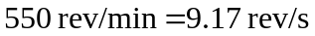, corresponding to a period of 0.109 s. a) From Eq. (3.29), 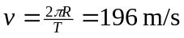. b) From either Eq. (3.30) or Eq. (3.31), 

